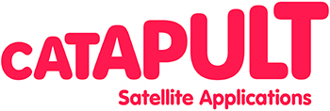

SARAD User Consultation Meeting Agenda

24th July
Satellite Applications Catapult

Meeting Objective: To present the SARAD Concept and solicit feedback from the SAR Community.

Agenda

09:30-10:00 Arrival and Coffee

10:00-10:20 Introduction to the Catapult
Nick Veck, Catapult

10:20-10:40 SARAD overview
Wyn Cudlip, Catapult

10:40-11:00 SARAD System requirements
Tom Lankester, Astrium GeoInformation

11:00- 11:20 Stakeholder Engagement
Charlotte Flindt, Astrium Satellites

11:20- 11:40 Training Course definition
Kajal Haria, Telespazio/Vega

11:40-12:00 Summary & Opportunities
Wyn Cudlip, Catapult

12:00- 12:30 Q&A

12:30- 13:00 Lunch and close

