Proposed changes to latitude and longitude representation on paper maps – tell us your thoughts

We’re considering changing the overlay showing latitude and longitude markers on Ordnance Survey paper maps. This would mean moving towards the overlay showing latitude and longitude used on GPS devices, to help bring digital navigation devices and paper maps closer together and work more in harmony. We believe this would have little impact on the majority of users of our paper maps; however, we would like your opinions on this change to ensure we fully consider all options and impacts before we make a final decision.

We’d like you to read the information below, and, if you would like to share your thoughts on how this would affect you, complete our short survey by Friday 3 October.

https://response.questback.com/ordnancesurvey/vc4rqrghun/

Most people use OS paper maps for location – either they want to know where they are, or where they want to get to (or even where they’ve just been). Once you have an OS paper map in front of you, there are a couple of ways of identifying the location you’re after – you can use National Grid, or latitude and longitude.

Most countries will define a ‘grid’ that can be overlaid onto a map of their country to help determine location. In Great Britain, the National Grid is the map reference system used on all Ordnance Survey maps to identify the position of any feature. The National Grid breaks Great Britain down into progressively smaller squares identified first by letters and then numbers.
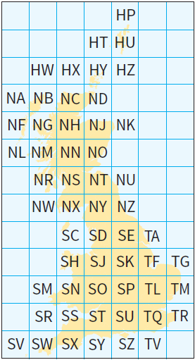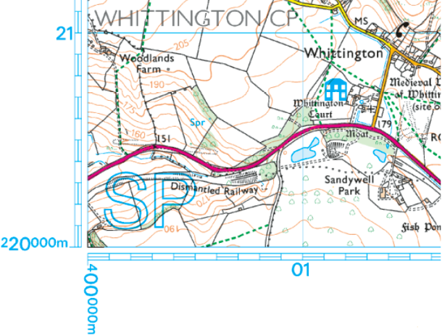
The National Grid for Great Britain

How it looks on OS paper maps, with two letters ‘SP’ defining the master grid square, and the numbers detailing the more precise location

Latitude is generally understood as your position in relation to the equator, which is 0º, and the distances you might be north or south of that line. Longitude is generally understood as your position in relation to the ‘Prime Meridian’, which for Great Britain (and much of the rest of the world) is sited at the Royal Observatory, Greenwich. This is also 0º.
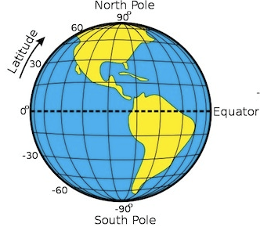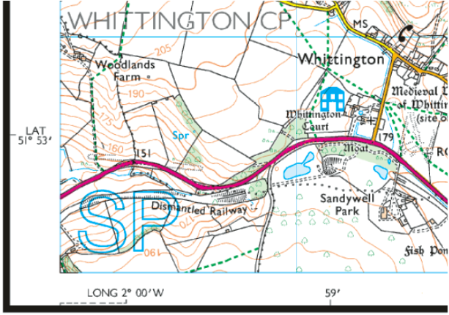
Global latitude and longitude

How it looks on OS paper maps, with the latitude and longitude numbers detailing the more precise location
Each of these methods will help you to pinpoint and find a location on a map.

To make life a little more complicated, the Earth is not a perfect sphere – it’s a bit squashed at the poles, so it bulges around the equator (like a Satsuma) – this shape is called ‘ellipsoid’. This can impact on how location is calculated; various interpretations have developed as geographers adapt latitude and longitude calculations to best fit the ‘ellipsoid’ in their part of the world – these are ‘datums’.

Ordnance Survey’s work in Great Britain uses the “Airy 1830 ellipsoid” to underpin the representation of latitude and longitude on OS paper maps, as this best fits Britain. However, in recent years, more and more map users are starting to use GPS devices, which operate on a datum with a wider geographical reach than just Great Britain. The datum that underpins GPS is called WGS84, and through sheer volume of usage is starting to become the default datum.

To support this increasing usage of GPS devices, OS are considering options that could help bring digital navigation devices and paper maps closer together and work more in harmony. Such an option could be the changing of the overlay on paper maps from Airy 1830 to WGS84.

It’s important for us to stress that this is NOT a change in the base map datum or the National Grid, which remains the Transverse Mercator Projection on the Airy 1830 ellipsoid, but it would result in a change in the datum of the latitude/longitude overlay only, adjusting where the latitude/longitude markers fall on the OS paper maps. For OS Landranger Maps, this movement may be as little as 2mm.
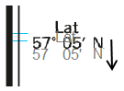

We realise that this is an important change to how our paper maps are presented, so we want to find out what the impact of implementing this change might be to you, the users of OS paper maps. The link below takes you through to a short survey of seven questions – please complete the survey and let us know how this might affect you if we were to move ahead with this change. The survey window closes Friday 3 October 2014, so please send your thoughts to us before then.

https://response.questback.com/ordnancesurvey/vc4rqrghun/

