Call for Expressions of Interest for UK contribution to MicroCarb Payload Data Ground Segment

Purpose

The UK Space Agency is seeking to identify UK organisations and institutes with the capability and desire to contribute to the development of the Payload Data Ground Segment for the MicroCarb mission.

The purpose of this call is to provide information on this opportunity, to articulate the expertise that is being sought to fulfil it and to seek expressions of interest from UK companies and organisations for consideration for this activity.

MicroCarb background

MicroCarb is a satellite mission to launch in 2020 designed to map sources and sinks of carbon dioxide (CO2). Its dispersive spectrometer instrument will be able to measure the total column concentration of CO2 with a high degree of precision over the whole Earth, and on a regional scale to inform climate change decision making.

CNES has partnered with the UK Space Agency (UKSA) on MicroCarb and UKSA has committed to funding and delivering a number of activities for MicroCarb in the UK- including contributions to the development of parts of the Payload Ground Segment (PLGS)

MicroCarb PLGS main functions

The main functions of the MicroCarb PLGS include:

- Payload management, performing instrument monitoring and control,
- Payload expertise function performing instrument calibration and characterization
- Product processing function, responsible for mission products generation
- Products expertise function responsible for quality monitoring and algorithm expertise.
- Data server function responsible for data transfers and operational data archive.
- Long-term data archive storing science data during mission life and post mission decommissioning.
- Data dissemination function responsible for the distribution of products to the science community as well as information about mission events to public.

The below diagram shows the components, highlighted in yellow, of the PLGS that require specific development and to which UK companies can be involved:
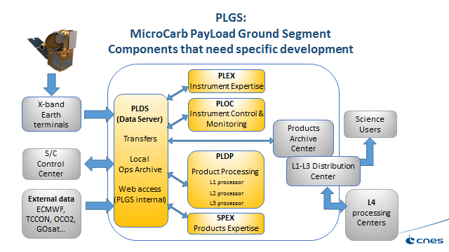

The PLGS will be developed in accordance to a CNES framework agreement involving four main companies- ATOS, CS-SI, CAPGEMINI and THALES SERVICES.

These prime companies will be asked to include UK companies. UK companies who respond to this call will be put forward for consideration by the primes when they are developing their proposals.

The requirements documents will be issued by CNES in December with an ITT expected in February 2018. These prime companies will be asked to include UK companies. Selection will be expected in May 2018.

An expression of interest should consist of Company name and UK address and a named contact with contact details to accompany a short statement providing an overview of your organisation’s capability and heritage in developing payload data ground segment and an indication of the nature of your interest in the MicroCarb PLGS.

Contact

Please forward all expressions of interest to Christopher McQuire at the UK Space Agency: christopher.mcquire@ukspaceagency.bis.gsi.gov.uk by 12pm on Monday 13th November 2017.

